User persons card

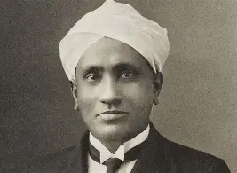 | Sir c.v Raman  If you meant his education, he studied physics at Presidency College, Madras, finishing his BA in 1904 and MA in 1907.
Sir C.V. Raman: Goals, Challenges, Motivation
Goals
- Science-la original research pannanum: Raman oda main goal, India-vulaye irundhu world-class science pannanum nu. Light, sound, and music instruments (veena, mridangam, tabla) pathi research pannaar.
- Indian science-ku suya mariyadhai: Indian scientists vellai-karanga-ku equal nu prove pannanum nu ninaichaar.
- Next generation-ku inspire pannanum: Pinnadi Raman Research Institute (1948) start pannaar, students-ku research opportunities kudukka.
Challenges
- Health problem: Ivar England poi padikkanum nu aasai pattaar, aana medical reasons-ala anuppala. Adhanala India-vule iruthu.
- Research career kedaikala: Padichu mudichadhum Kolkata-la Finance Service-la Assistant Accountant General aa velai paarthaar. Research-ku full-time job illa.
- Limited resources: Kolkata-la Indian Association for the Cultivation of Science (IACS)-la velai mudinja piragu, spare time-la experiments pannaar. Equipment romba simple-aa, kammi cost-la dhaan irundhadhu.
- Colonial period: Indian scientists-ku funding, labs, and recognition kammi-yaa irundhadhu.
- Institution-la conflicts: Bangalore-la Indian Institute of Science director aa irundha time-la sila disagreements vandhadhu, adhunala director post-ah vittuttu Raman Research Institute-ku focus pannaar.
Motivation
- Curiosity: 1921-la kappal-la England pogum podhu, kadal ethanala neela-ma theriyudhu nu yosichaar. Adhu dhaan Raman Effect-ku starting point. Ippadi simple question-la irundhu periya discovery vandhadhu.
- Family background: Appa physics and maths lecturer, so chinna vayasulayae books and science-la interest irundhadhu.
- Self-belief: Resources illanaalum, “good science-ku periya lab thevai illa, clear thinking dhaan thevai” nu nambinaar.
- Desh bakthi: India-ku science-la perumai thedi tharanum nu aasai.
Major Achievements
- 1928 (Feb 28): Raman Effect kandupidichaar. Adhanaala Feb 28 National Science Day.
- 1930: Physics-ku Nobel Prize. Asia-vulaye science-la Nobel vaangina first person.
- 1954: Bharat Ratna.
.

Online Learning Platform
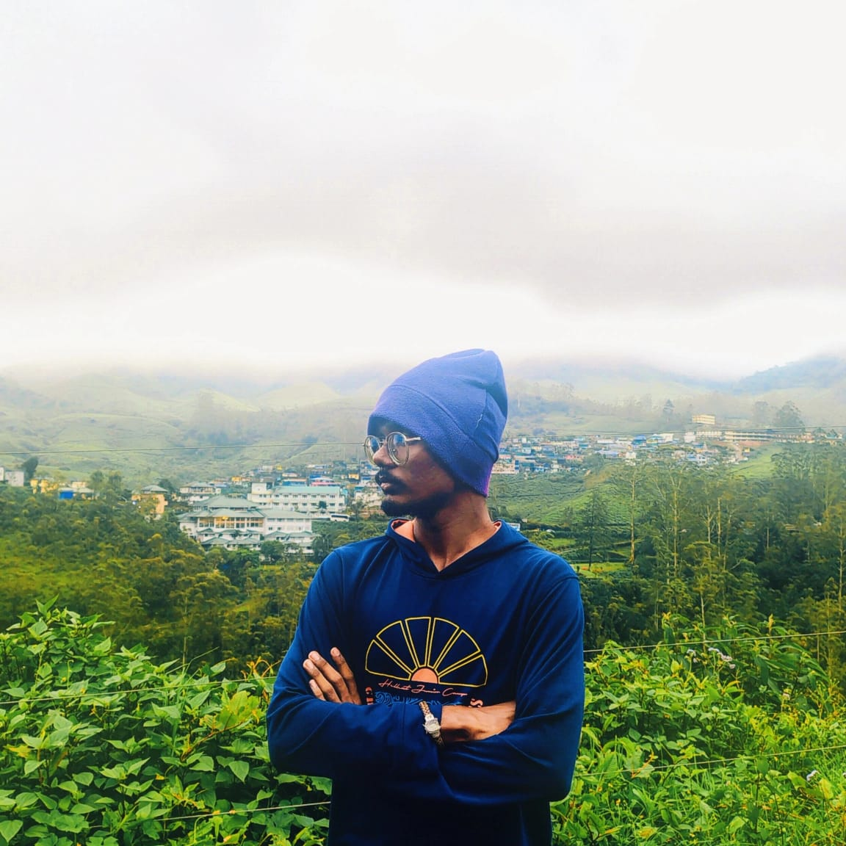 | RITTHISH  Age 17 : First-year BCA Student
GOALS
Build a strong foundation in programming and computer fundamentals to excel in his BCA course and future IT career.
CHALLENGES
Struggles with abstract programming concepts taught in class; loses confidence when stuck on coding errors with no one to ask immediately.
TECHNOLOGY USAGE
Mobile-first; codes on a laptop during study hours, watches short coding tutorials, and uses YouTube and coding forums for quick fixes.
MOTIVATIONS
Scoring well in semester exams, impressing his parents, and becoming job-ready for a software role after graduation.

